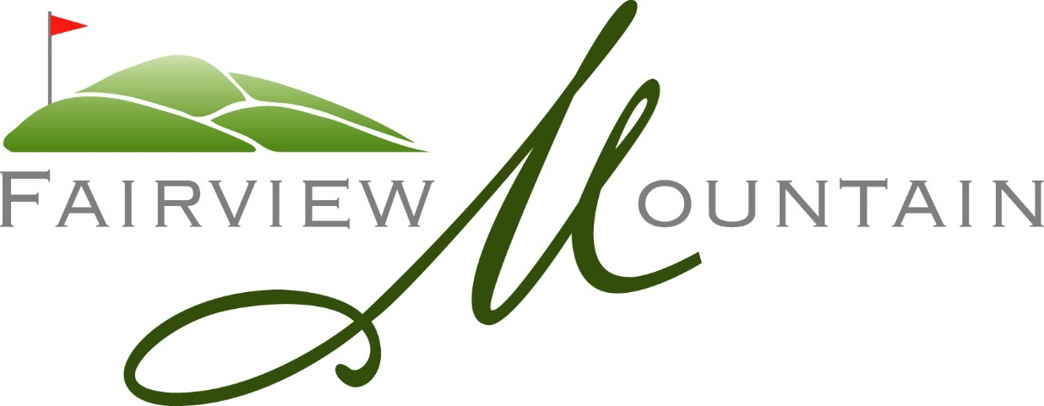

Trial Memberships

For the 2020 Season Fairview Mountain will be offering trial memberships. Any golfers interested in playing the course can join and enjoy “full membership privileges” for the entire season by paying full adult membership dues with no commitment to the club’s initiation fee within that first year. At seasons end, based on their experiences, trial members can decide if FMGC is the club for them and meet with the clubs GM to discuss the many options surrounding payment on the initiation fee.

For more information, please contact the clubs GM/Director of Golf Operations, Brian McDonald either via email at bmcdonald@fairviewmountain.com or by phone at (250) 498 – 6050.

